Report on
Self learning practice
For the course
Database management systems
B24CS2T06
By
Jesbin Shaju – MAC24AIM040
Jess Johnson –MAC24AIM041
Jewel Thomas-MAC24AIM042
K M Mohammed Ansaf- MAC24AIM043

S4 AIML
Dept Of Computer Science And Engineering
Mar Athanasius College Of Engineering
Kothamangalam
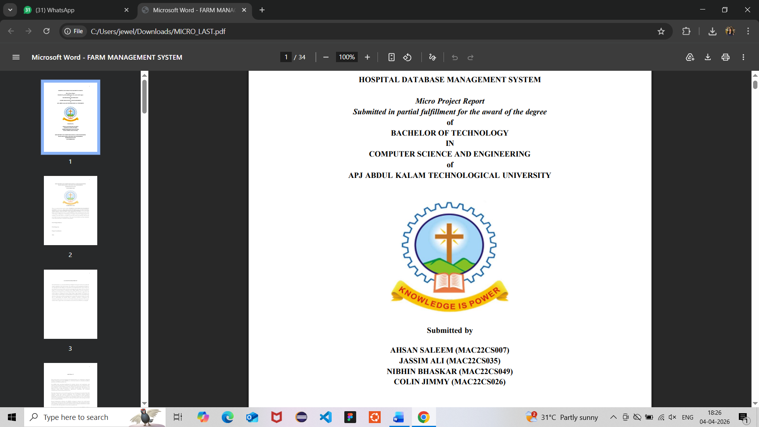
April 2026

ABSTRACT
The Student Roommate & PG Finder with Compatibility Matching system is a database-driven web application designed to help students find suitable accommodation and compatible roommates when relocating to new cities. The system allows users to create profiles based on preferences such as budget, food habits, sleep schedule, and cleanliness. Using SQL-based logic, it matches students with compatible roommates and suggests relevant PG accommodations.
The application is developed using TypeScript for the frontend and PostgreSQL for backend database management. Various DBMS concepts such as DDL, DML, DQL, joins, and nested queries are used to ensure efficient data handling and retrieval of information.
Additional features include rent splitting, complaint tracking, and a review system to enhance transparency and user experience. The system also ensures data integrity using constraints, triggers, and transactions. Overall, the project demonstrates the practical application of database management concepts in solving real-world accommodation problems while improving user convenience and efficiency.

INTRODUCTION

In today’s rapidly growing urban environment, students frequently relocate to different cities in pursuit of higher education. One of the major challenges they face during this transition is finding suitable accommodation and compatible roommates. Traditional methods of searching for Paying Guest (PG) accommodations, such as local brokers, advertisements, or informal networks, are often time-consuming, unreliable, and lack transparency. Additionally, the absence of compatibility consideration between roommates can lead to discomfort and conflicts in shared living spaces.
With the advancement of technology, database-driven applications have become essential in managing and organizing large amounts of data efficiently. This project, titled Student Roommate & PG Finder with Compatibility Matching, aims to address these challenges by providing a centralized platform that integrates accommodation search with roommate matching. The system allows students to create profiles based on their preferences such as budget, food habits, sleep schedule, and cleanliness, enabling better compatibility assessment.
The application is developed using TypeScript for the frontend and PostgreSQL for backend database management. It utilizes core Database Management System (DBMS) concepts such as data definition, data manipulation, and data querying to store, manage, and retrieve information efficiently. Advanced features like joins, nested queries, triggers, and transactions are implemented to ensure data consistency and reliable system performance.
Furthermore, the system includes additional functionalities such as rent splitting, complaint management, and review mechanisms, which enhance user experience and promote transparency. By combining efficient data handling with user-centric design, this project demonstrates how DBMS concepts can be applied to solve real-world problems effectively and improve the overall accommodation search experience for students.

THEORETICAL BACKGROUND

A Database Management System (DBMS) is a software system that enables the efficient storage, retrieval, and management of data in a structured manner. It provides mechanisms to define, manipulate, and control data while ensuring consistency, security, and integrity. In this project, a relational database model is used, where data is organized into tables consisting of rows and columns, and relationships between entities are maintained using keys.
The foundation of this system lies in Structured Query Language (SQL), which is used to perform various operations on the database. SQL is categorized into different components such as Data Definition Language (DDL), Data Manipulation Language (DML), and Data Query Language (DQL). DDL is used to create and define database structures, DML is used to insert, update, and delete data, and DQL is used to retrieve data efficiently. These operations form the core of the system’s functionality.
Normalization is another important concept applied in this project to eliminate redundancy and ensure efficient data organization. The database is structured up to Third Normal Form (3NF), which helps in reducing data anomalies and improving consistency. Relationships between entities such as students, PG accommodations, and bookings are maintained using primary keys and foreign keys, ensuring referential integrity.
Advanced SQL concepts such as joins and nested queries are used to perform complex data retrieval operations. Joins allow data to be combined from multiple tables, while nested queries help in filtering and processing data based on specific conditions. These techniques are essential for implementing features like compatibility matching and retrieving relevant accommodation details.
The project also incorporates procedural extensions of SQL, such as triggers and functions, to automate tasks and enforce business rules. Triggers are used to automatically perform actions when certain events occur in the database, while functions help in performing repeated calculations efficiently. Additionally, transaction control mechanisms such as COMMIT and ROLLBACK ensure data reliability during critical operations.
Overall, the theoretical foundation of this project is based on core DBMS principles, relational database design, and SQL operations, which together enable the development of a robust, efficient, and scalable system for managing student accommodation and roommate matching.

IMPLEMENTATION DETAILS
The implementation of the Student Roommate & PG Finder with Compatibility Matching system follows a layered architecture consisting of frontend, backend, and database components. The frontend is developed using TypeScript, which provides a dynamic and interactive user interface for data input and display. The backend is supported by PostgreSQL, which handles data storage, query execution, and overall database management. The system operates on a client-server model, where user requests are processed and responded to through structured database interactions.
At the Operating System (OS) level, the system relies on process management to handle multiple user requests simultaneously. Each user interaction, such as login, registration, or search, is treated as a separate process or thread. The OS scheduler efficiently allocates CPU time to these processes, ensuring smooth multitasking and responsiveness of the application. This is particularly important when multiple users access the system concurrently.
Memory management plays a crucial role in storing active data and query results temporarily. When a query is executed in PostgreSQL, the OS allocates memory for query processing, buffering, and caching. Frequently accessed data may be stored in cache memory to improve performance and reduce disk access time. This enhances the speed of operations such as retrieving PG details or matching roommate profiles.
File system management is used to store database files persistently on disk. PostgreSQL maintains data files, log files, and transaction logs within the file system. The OS ensures efficient read and write operations, allowing the database to retrieve and update records reliably. Backup and recovery mechanisms are also supported through log files to prevent data loss.
Concurrency control is another important aspect managed at both the DBMS and OS levels. When multiple users attempt to access or modify the same data, locking mechanisms are used to prevent conflicts. The OS supports synchronization techniques, while PostgreSQL implements transaction isolation levels to ensure data consistency and integrity.
The system also utilizes inter-process communication (IPC) between the application and database server. When a user submits a request, the frontend sends data to the backend, which communicates with the PostgreSQL server through structured queries. The OS facilitates this communication using system calls and networking protocols.
Security is enforced through user authentication and access control mechanisms. The OS provides basic security features such as user permissions and process isolation, while the database uses role-based access control to restrict unauthorized operations. This ensures that sensitive data such as user profiles and booking details are protected.

EXPERIMENTAL RESULTS

The system was tested using sample data to evaluate its performance and functionality. The roommate matching feature provided accurate results based on user preferences such as budget and lifestyle habits. PG search and data retrieval operations were performed efficiently using SQL queries with minimal response time.
Transaction operations like booking were handled reliably using COMMIT and ROLLBACK, ensuring data consistency. Triggers and functions worked correctly by automating updates such as timestamps and complaint records. The system also handled multiple user requests smoothly, demonstrating effective concurrency control.
Overall, the results indicate that the system performs efficiently, maintains data integrity, and successfully implements key DBMS concepts in a practical scenario.

SDG MAPPING

The Student Roommate & PG Finder with Compatibility Matching system aligns with the Sustainable Development Goals (SDGs) proposed by the United Nations by addressing challenges related to student accommodation and urban living.
The project primarily supports SDG 11 – Sustainable Cities and Communities by improving access to safe, affordable, and organized housing for students. It helps in better utilization of available PG accommodations and promotes efficient urban living.
It also contributes to SDG 4 – Quality Education by reducing the stress and time students spend searching for accommodation, allowing them to focus more on their academic activities and overall well-being.
Additionally, the system supports SDG 8 – Decent Work and Economic Growth by providing landlords with a structured platform to list their properties and connect with potential tenants, thereby supporting small-scale rental businesses.
Overall, the project demonstrates how technology and database systems can contribute to sustainable development by improving accessibility, efficiency, and quality of living for students.

CONCLUSION

The Student Roommate & PG Finder with Compatibility Matching system successfully demonstrates the practical application of Database Management System concepts in solving real-world problems faced by students. The project provides an efficient platform for finding suitable accommodation and compatible roommates based on user preferences, improving convenience and decision-making.
By integrating core DBMS concepts such as SQL queries, normalization, triggers, functions, and transaction management, the system ensures data integrity, reliability, and efficient performance. The use of a structured database enables organized storage and quick retrieval of information, making the system scalable and user-friendly.
Additional features such as roommate matching, review systems, complaint handling, and rent splitting enhance the overall functionality and usability of the platform. The system also ensures smooth handling of multiple user requests, demonstrating effective resource management and concurrency control.
Overall, this project highlights how database-driven applications can be effectively used to address everyday challenges, providing a reliable, efficient, and practical solution for student accommodation management.

